**Smart water system**

The project objectives of a smart water system typically include:

1. Water Conservation: Implementing technology to monitor and manage water usage efficiently to reduce wastage.
2. Real-time Monitoring: Developing systems that can continuously monitor water quality, usage, and infrastructure to detect issues promptly.
3. Leak Detection: Detecting and preventing leaks in the water supply system to minimize water loss.
4. Data Analysis: Collecting and analyzing data to improve water management, distribution, and infrastructure maintenance.
5. Remote Control: Enabling remote control of water infrastructure, such as valves and pumps, for efficient operation.
6. Customer Engagement: Providing consumers with tools and information to manage their water usage effectively.
7. Sustainability: Integrating renewable energy sources and eco-friendly practices to reduce the environmental impact of water systems.
8. Cost Reduction: Optimizing the operation and maintenance of water systems to reduce operational costs.
9. Compliance: Ensuring that water quality and supply meet regulatory standards.
10. Scalability: Designing systems that can scale to accommodate population growth and changing needs.
11. Resilience: Enhancing the system’s ability to withstand and recover from disasters and disruptions.

These objectives aim to create a more efficient, sustainable, and resilient water supply system through the use of smart technologies and data-driven management.

* Setting up IoT sensors for a smart water system involves specific considerations to monitor and manage water resources efficiently. Here’s how you can set up IoT sensors for such a system:

1. **Define Objectives**: Clearly outline the goals of your smart water system, such as monitoring water quality, usage, leak detection, and more.
2. **Select Sensors**: Choose appropriate sensors based on your objectives. For a smart water system, you may need sensors for water quality (pH, turbidity, chemical parameters), flow rate, pressure, temperature, and leak detection.
3. **Connectivity**: Select the appropriate connectivity technology, considering factors like range, power consumption, and data transmission speed. LoRa, NB-IoT, or cellular networks are common choices.
4. **Microcontroller/Processor**: Use microcontrollers or processors to collect data from sensors, process it, and transmit it to a central system. Ensure the hardware is suitable for the environmental conditions.
5. **Power Supply**: Depending on sensor locations, consider battery-powered sensors, solar panels, or even harvesting energy from the water flow.
6. **Data Storage**: Set up a robust data storage system, which may include cloud-based solutions, to securely store the sensor data.
7. **Data Transmission**: Implement secure data transmission protocols to send data from the sensors to the central system. Use encryption to protect data in transit.
8. **Data Processing**: Develop algorithms to process and analyze the data, enabling you to detect anomalies, predict system issues, and optimize water usage.
9. **User Interface**: Create a user-friendly interface for both end-users and administrators to access and visualize data in real-time.
10. **Security**: Pay special attention to security as water systems can be critical infrastructure. Protect against unauthorized access, data breaches, and cyber threats.
11. **Scalability**: Design the system to accommodate additional sensors and infrastructure as your smart water network expands.
12. **Testing and Calibration**: Rigorously test and calibrate the sensors to ensure data accuracy. Calibrate for changing environmental conditions if necessary.
13. **Maintenance and Updates**: Plan for routine maintenance and firmware updates to keep the system running smoothly and up-to-date.
14. **Compliance**: Ensure your smart water system complies with relevant regulations and standards, especially those related to water quality and environmental protection.
15. **Deployment**: Carefully deploy sensors at key locations, such as reservoirs, pipelines, and treatment plants.
16. **Monitoring and Alerts**: Implement continuous monitoring and alert systems to notify operators of any issues, such as leaks, water quality anomalies, or equipment failures.
17. **Data Privacy**: Address data privacy concerns, especially if the system collects data from residential or commercial users. Follow data protection regulations.
18. **Documentation**: Maintain comprehensive documentation of your smart water system setup for future reference, troubleshooting, and expansion.

By following these steps, you can create an effective and efficient IoT sensor setup for a smart water system that helps conserve water resources, improve water quality, and reduce operational costs.

* Developing a mobile app for a smart water system is a crucial component for providing users with access to real-time data and control over the system. Here’s a high-level overview of the steps involved in mobile app development for a smart water system:

1. **Define Objectives**:

- Clearly define the objectives of the mobile app. What functionalities will it offer to users in the context of the smart water system?

2. **User Requirements**:

- Understand the needs of different user groups (e.g., consumers, administrators, water utility personnel) and create user personas.

3. **Select Mobile Platforms**:

- Decide whether to develop the app for iOS, Android, or both platforms. This choice depends on your target audience and budget.

4. **Design User Interface (UI)**:

- Create a user-friendly and intuitive UI/UX design to ensure users can easily access and interpret data and control the system.

5. **Features and Functionality**:

- Determine the features the app will offer, such as real-time water quality monitoring, water consumption tracking, billing information, and leak detection alerts.

6. **Integration**:

- Integrate the app with the central system and IoT sensors to access and display real-time data.

7. **Authentication and Security**:

- Implement secure user authentication mechanisms to protect sensitive water system data.

8. **Data Visualization**:

- Develop data visualization tools (graphs, charts, maps) to help users understand water system data.

9. **Control Features**:

- If applicable, enable users to control certain aspects of the water system, like valve operation or reporting issues.

10. **Notifications and Alerts**:

- Set up push notifications to alert users about important events, such as water quality issues or leak detections.

11. **Offline Functionality**:

- Ensure the app can work offline and synchronize data when the device is back online.

12. **Testing and Quality Assurance**:

- Thoroughly test the app for functionality, security, and performance. Address any issues or bugs that arise during testing.

13. **Compliance and Data Privacy**:

- Ensure the app complies with relevant data protection and privacy regulations, especially if it handles sensitive user data.

14. **Documentation and Support**:

- Prepare user documentation and provide customer support for app users.

15. **Deployment**:

- Publish the app on the respective app stores (Apple App Store, Google Play Store) for users to download.

16. **Maintenance and Updates**:

- Continuously update the app to improve functionality, fix bugs, and adapt to evolving user needs.

17. **User Training**:

- If necessary, provide training or user education to help users make the most of the app.

18. **Feedback and Improvement**:

- Collect user feedback and use it to make enhancements to the app based on user experience and needs.

* Mobile app development for a smart water system is a complex process that requires collaboration between app developers and experts in water management and IoT technologies. It should prioritize usability, data security, and real-time functionality to provide users with a valuable tool for managing their water resources.

Integrating Raspberry Pi into a smart water system can enhance its capabilities for data collection, processing, and control. Here’s an overview of how to integrate Raspberry Pi into a smart water system:

1. **Define Objectives**:

- Clearly define the objectives of integrating Raspberry Pi into the smart water system. What specific tasks or functions do you want the Raspberry Pi to perform?

2. **Hardware Selection**:

- Choose the appropriate Raspberry Pi model based on the project requirements. Consider factors like processing power, connectivity options, and available GPIO pins.

3. **Sensor Integration**:

- Connect water quality sensors, flow meters, pressure sensors, or other relevant sensors to the Raspberry Pi using GPIO pins, I2C, SPI, or USB interfaces.

4. **Data Collection**:

- Develop code to collect data from the sensors. This can involve reading sensor values, such as water quality parameters or flow rates.

5. **Data Processing**:

- Use the Raspberry Pi to process the collected data. Implement algorithms to analyze and interpret sensor data, detect anomalies, and make real-time decisions if necessary.

6. **Connectivity**:

- Integrate connectivity options like Wi-Fi, Ethernet, or cellular modules to enable data transmission to a central system or the cloud.

7. **Database Storage**:

- Set up a database on the Raspberry Pi to store historical data for analysis and reporting. Popular choices include SQLite or MySQL.

8. **User Interface**:

- Develop a web-based or mobile app interface that allows users to access the data and control the system. The Raspberry Pi can host this interface locally or communicate with a remote server for data display.

9. **Security**:

- Implement robust security measures, such as firewalls and data encryption, to protect the Raspberry Pi and the data it handles.

10. **Remote Control**:

- If needed, enable remote control of water system components using the Raspberry Pi. For example, you could remotely shut off valves or pumps.

11. **Testing and Calibration**:

- Rigorously test the Raspberry Pi’s functionality, including sensor readings and data processing. Calibrate sensors for accurate measurements.

12. **Power Supply**:

- Ensure a reliable power supply for the Raspberry Pi, considering backup power options to prevent data loss during outages.

13. **Documentation**:

- Maintain thorough documentation of the Raspberry Pi setup, including wiring diagrams, software configurations, and maintenance procedures.

14. **Compliance and Regulations**:

- Ensure that the system complies with relevant water quality and environmental regulations, especially if the data collected is used for regulatory purposes.

15. **Maintenance and Updates**:

- Plan for regular maintenance and updates to keep the Raspberry Pi and associated software up-to-date and operating smoothly.

16. **Scalability**:

- Design the system to accommodate additional sensors or Raspberry Pi units as the smart water system expands.

By integrating Raspberry Pi into your smart water system, you can enhance data collection and processing capabilities, enabling real-time monitoring and control while reducing the overall cost of implementation.

Implementing code for a smart water system is a complex task, and the specifics depend on the hardware and software components you’re using. Here’s a general outline of how you can approach the code implementation:

1. **Select a Programming Language**:

- Choose a suitable programming language for your smart water system. Common choices include Python, C/C++, Java, and JavaScript.

2. **Hardware Interface**:

- Write code to interface with the hardware components, such as sensors, microcontrollers (e.g., Raspberry Pi), and communication modules (e.g., Wi-Fi, LoRa, cellular).

3. **Data Collection**:

- Develop code to collect data from the sensors. Depending on the sensors used, this may involve reading analog or digital sensor values and converting them into meaningful data.

4. **Data Processing**:

- Implement data processing algorithms to analyze and interpret the sensor data. This can include calculations for water quality, flow rates, or leak detection.

5. **Data Transmission**:

- Write code for data transmission to central servers or the cloud. Use secure communication protocols (e.g., MQTT, HTTPS) to protect data during transmission.

6. **Database Management**:

- Set up and code interactions with a database to store and manage historical data. You might use databases like SQLite, MySQL, or cloud-based solutions like AWS DynamoDB.

7. **User Interface**:

- Develop a user interface, which could be a web-based dashboard, a mobile app, or a local interface, to visualize data and enable user interaction.

8. **Security**:

- Implement security measures to protect the system from unauthorized access, data breaches, and cyber threats. This includes user authentication, encryption, and secure API endpoints.

9. **Notifications and Alerts**:

- Set up code for sending notifications and alerts to users or system administrators in response to critical events, such as water quality issues or leaks.

10. **Remote Control**:

- If applicable, implement code to allow remote control of water system components, such as valves or pumps.

11. **Testing and Calibration**:

- Thoroughly test the code, including sensor readings, data processing, and data transmission. Calibrate sensors for accurate measurements.

12. **Documentation**:

- Maintain comprehensive documentation that includes code comments, system architecture diagrams, and user guides.

13. **Compliance and Regulations**:

- Ensure that the code and the overall system comply with relevant water quality and environmental regulations.

14. **Maintenance and Updates**:

- Plan for regular maintenance and code updates to address bugs, improve functionality, and adapt to changing requirements.

15. **Scalability**:

- Design the code to be scalable, allowing you to add more sensors, users, or features as your smart water system grows.

16. **User Training**:

- Provide training and support for users and administrators to effectively use and maintain the system.

Remember that the specific code implementation will vary depending on the sensors, microcontrollers, and other components you’re using, as well as the unique requirements of your smart water system. It’s essential to follow best practices for coding, security, and data management throughout the development process.

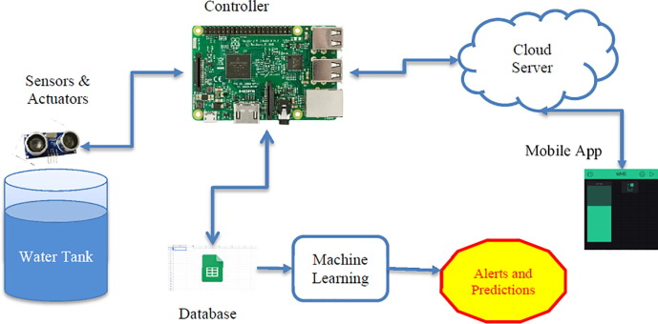

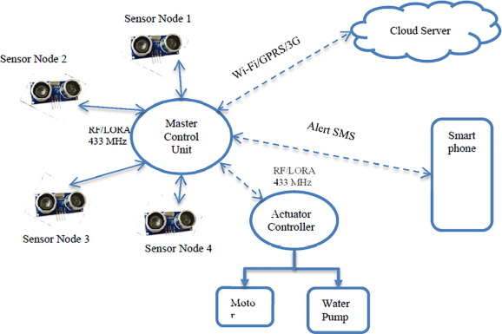

A real-time water consumption monitoring system can significantly promote water conservation and sustainable practices in several ways:

1. **Data Visibility and Awareness**:

- By providing real-time data on water consumption, users, businesses, and water utilities gain visibility into their water usage patterns. This increased awareness can encourage them to be more mindful of their water consumption.

2. **Behavioral Change**:

- Real-time monitoring allows users to see the immediate impact of their actions on water usage. This feedback can motivate individuals and organizations to adopt more water-efficient practices.

3. **Leak Detection**:

- The system can detect and alert users to leaks or abnormal water usage patterns in real-time. Early detection of leaks can prevent significant water wastage and damage to